Module : 2 (HTML AND CSS)

1. Define the terms: Website, Webpage, Web browser, Web server, HTML, CSS

ANS :

Web site : A set of interconnected webpages, usually including a homepage,

generally located on the same server, and prepared and maintained as a

collection of information.

Web Page : A web page or webpage is a document, commonly written in HTML,

that is viewed in an Internet browser. A web page can be accessed by

entering.

Web browser : A web browser is a software application used to retrieve data from

webpages,whereas, Search Engine is kind of a website where a user can

search for information.

Web Server : A *web server* is a computer that runs websites. It's a computer program

that distributes web pages as they are requisitioned.

HTML : HTML is a Markup Language. HTML is used to create web pages and web

applications. HTML is widely used language.

HTML stands for HyperText web.

CSS : CSS is used to control the style of a web document in a simple and easy way.

CSS is the acronym for "Cascading Style Sheet".

2. Create a webpage to show “This is my first HTML page”

ANS :

<!DOCTYPE html>

<html lang="en">

<head>

    <meta charset="UTF-8">

    <meta http-equiv="X-UA-Compatible" content="IE=edge">

    <meta name="viewport" content="width=device-width, initial-scale=1.0">

    <title>Document</title>

</head>

<body>

    This is my first webpage

</body>

</html>

Output:

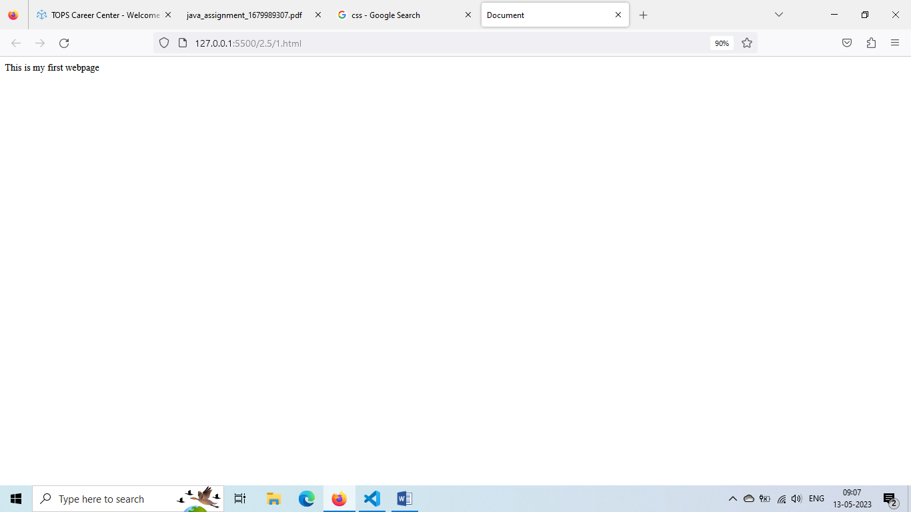

3. Display top 10 IT companies list in html webpage

ANS :

<!DOCTYPE html>

<html lang="en">

<head>

    <meta charset="UTF-8">

    <meta http-equiv="X-UA-Compatible" content="IE=edge">

    <meta name="viewport" content="width=device-width, initial-scale=1.0">

    <title>Document</title>

</head>

<body>

    <li>1. Hyperlink InfoSystem</li>

    <li>2. Accenture</li>

    <li>3. Capgemini India Pvt ltd</li>

    <li>4. Zensar Technologies</li>

    <li>5. Mphasis</li>

    <li>6. WillowTree Apps</li>

    <li>7. Tata Consultancy Services</li>

    <li>8. Infosys</li>

    <li>9. Tech Mahindra</li>

    <li>10. HData Systems</li>

</body>

</html>

Output :

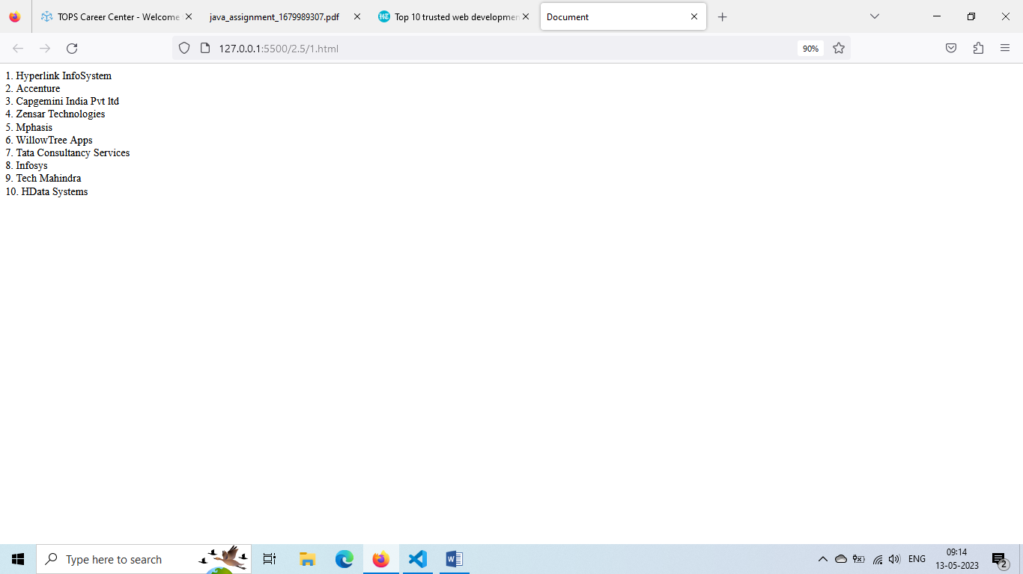

4. Create a dropdown list

ANS :

<!DOCTYPE html>

<html lang="en">

<head>

    <meta charset="UTF-8">

    <meta http-equiv="X-UA-Compatible" content="IE=edge">

    <meta name="viewport" content="width=device-width, initial-scale=1.0">

    <title>Document</title>

</head>

<body>

    <select id="qua" class="qua">

        <option label="Select Qualification: "></option>

        <option label="Arts"></option>

        <option label="Commerce"></option>

        <option label="Science"></option>

      </select>

</body>

</html>

Output :

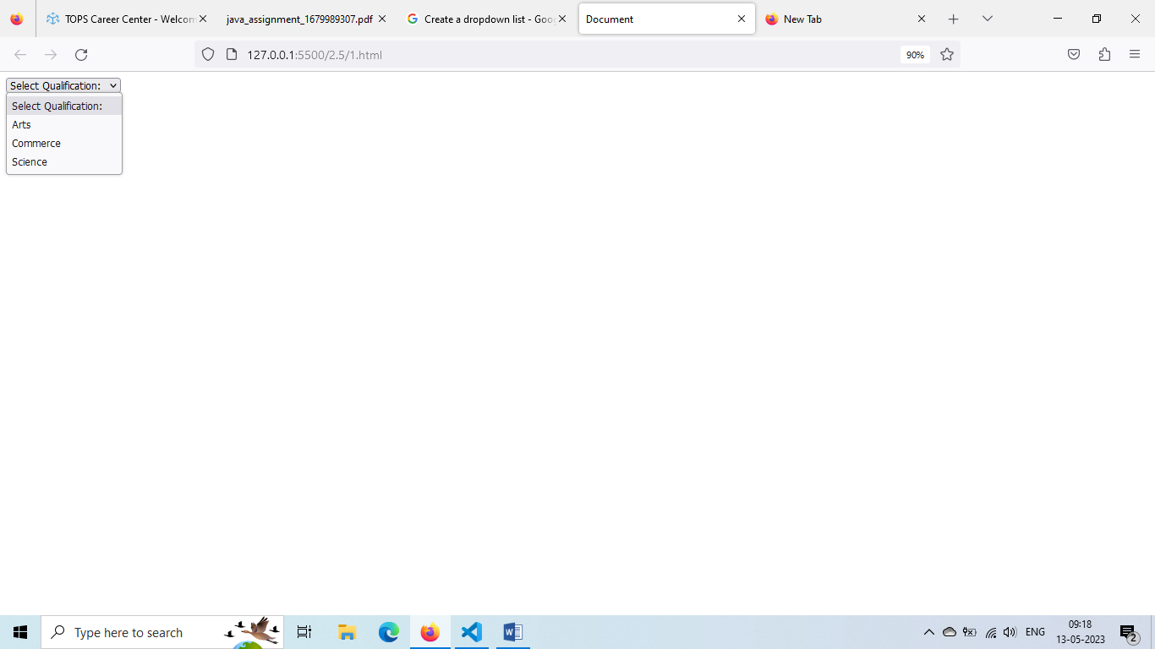

5. Create a Table Of college Management system using row span & col span.ANS :

<!DOCTYPE html>

<html lang="en">

<head>

    <meta charset="UTF-8">

    <meta http-equiv="X-UA-Compatible" content="IE=edge">

    <meta name="viewport" content="width=device-width, initial-scale=1.0">

    <title>MAHESH</title>

</head>

<h2 align="right">Table using colspan and rowspan</h2>

<body>

    <table border="3" cellpadding="5" cellspacing="5" align="right" bgcolor="redblue">

        <tr>

            <th rowspan="9">A</td>

            <th rowspan="8">B</td>

                <th rowspan="7">C</td>

                    <th rowspan="6">D</td>

                        <th rowspan="5">E</td>

                            <th rowspan="4">F</td>

            <td>AH</td>

            <th rowspan="4">H</th>

                <th rowspan="5">I</th>

                    <th rowspan="6">J</th>

                        <th rowspan="7">K</th>

                        <th rowspan="8">L</th>

                        <th rowspan="10">M</th>

        </tr>

        <tr>

            <!-- <td>1</td> -->

            <!-- <td>2</td> -->

            <!-- <td>3</td> -->

            <!-- <td>4</td> -->

            <!-- <td>5</td> -->

            <!-- <td>6</td> -->

            <td>H</td>

            <!-- <td>8</td> -->

           <!-- <td>9</td> -->

            <!-- <td>10</td> -->

            <!-- <td>11</td> -->

            <!-- <td>12</td> -->

            <!-- <td>13</td> -->

        </tr>

        <tr>

            <!-- <td>1</td> -->

            <!-- <td>2</td> -->

            <!-- <td>3</td> -->

            <!-- <td>4</td> -->

            <!-- <td>5</td> -->

            <!-- <td>6</td> -->

            <td>GH</td>

            <!-- <td>8</td> -->

            <!-- <td>9</td> -->

            <!-- <td>10</td> -->

            <!-- <td>11</td> -->

            <!-- <td>12</td> -->

            <!-- <td>13</td> -->

        </tr>

        <tr>

            <!-- <td>1</td> -->

            <!-- <td>2</td> -->

            <!-- <td>3</td> -->

            <!-- <td>4</td> -->

            <!-- <td>5</td> -->

            <!-- <td>6</td> -->

            <td>N</td>

            <!-- <td>8</td> -->

            <!-- <td>9</td> -->

            <!-- <td>10</td> -->

            <!-- <td>11</td> -->

            <!-- <td>12</td> -->

            <!-- <td>13</td> -->

        </tr>

        <tr>

            <!-- <td>1</td> -->

            <!-- <td>2</td> -->

            <!-- <td>3</td> -->

            <!-- <td>4</td> -->

            <!-- <td>5</td> -->

            <th colspan="3">O</th>

            <!-- <td>7</td> -->

            <!-- <td>8</td> -->

            <!-- <td>9</td> -->

            <!-- <td>10</td> -->

            <!-- <td>11</td> -->

            <!-- <td>12</td> -->

            <!-- <td>13</td> -->

        </tr>

        <tr>

            <!-- <td>1</td> -->

            <!-- <td>2</td> -->

            <!-- <td>3</td> -->

            <!-- <td>4</td> -->

            <th colspan="5">P</th>

            <!-- <td>6</td> -->

            <!-- <td>7</td> -->

            <!-- <td>8</td> -->

            <!-- <td>9</td> -->

            <!-- <td>10</td> -->

            <!-- <td>11</td> -->

            <!-- <td>12</td> -->

            <!-- <td>13</td> -->

        </tr>

        <tr>

            <!-- <td>1</td> -->

            <!-- <td>2</td> -->

            <!-- <td>3</td> -->

            <th colspan="7">Q</th>

            <!-- <td>5</td> -->

            <!-- <td>6</td> -->

            <!-- <td>7</td> -->

            <!-- <td>8</td> -->

            <!-- <td>9</td> -->

            <!-- <td>10</td> -->

            <!-- <td>11</td> -->

            <!-- <td>12</td> -->

            <!-- <td>13</td> -->

        </tr>

        <tr>

            <!-- <td>1</td> -->

            <!-- <td>2</td> -->

            <th colspan="2">R</th>

            <!-- <td>4</td> -->

            <td>S</td>

            <td>T</td>

            <td>U</td>

            <td>V</td>

            <td>w</td>

            <th colspan="2">X</th>

            <!-- <td>11</td> -->

            <!-- <td>12</td> -->

            <!-- <td>13</td> -->

        </tr>

        <tr>

            <!-- <td>1</td> -->

            <th colspan="11">Y</th>

            <!-- <td>3</td>

            <!-- <td>4</td> -->

            <!-- <td>5</td> -->

            <!-- <td>6</td> -->

            <!-- <td>7</td> -->

            <!-- <td>8</td> -->

            <!-- <td>9</td> -->

            <!-- <td>10</td> -->

            <!-- <td>11</td> -->

            <!-- <td>12</td> --> -->

            <!-- <td>13</td> -->

        </tr>

        <tr>

            <th colspan="2">Z</th>

            <!-- <td>2</td> -->

            <td>1</td>

            <td>2</td>

            <td>3</td>

            <td>4</td>

            <td>5</td>

            <td>6</td>

            <td>7</td>

            <td>8</td>

            <td>9</td>

            <td>10</td>

            <!-- <td>13</td> -->

        </tr>

    </table>

<br>

<table border="1" cellpading="3" cellspacing="4" align="center">

    <tr>

        <th colspan="10">tableA(2B) <br>

            Authantic Ownership interest Of Ethentic nations with one of more Aethentable Persons

        Full Power CommercialTelevision Station-2-13</th>

        <!-- <td>2</td> -->

        <!-- <td>3</td> -->

        <!-- <td>4</td> -->

        <!-- <td>5</td> -->

        <!-- <td>6</td> -->

        <!-- <td>7</td> -->

        <!-- <td>8</td> -->

        <!-- <td>9</td> -->

        <!-- <td>10</td> -->

    </tr>

    <tr>

        <th colspan="2" rowspan="3">ethucity</th>

        <!-- <td>2</td> -->

        <th colspan="8">No Of Station and Percent Of Total</th>

        <!-- <td>4</td> -->

        <!-- <td>5</td> -->

        <!-- <td>6</td> -->

        <!-- <td>7</td> -->

        <!-- <td>8</td> -->

        <!-- <td>9</td> -->

        <!-- <td>10</td> -->

    </tr>

    <tr>

        <!-- <td>1</td> -->

        <!-- <td>2</td> -->

        <th colspan="2">Nationally</th>

        <!-- <td>4</td> -->

        <th colspan="2">station <br> DMA 1-50</th>

        <!-- <td>6</td> -->

        <th colspan="2">DMA <br>51-100</th>

        <!-- <td>8</td> -->

        <th colspan="2">DMA <br> 100+</th>

        <!-- <td>10</td> -->

    </tr>

    <tr>

        <!-- <td>1</td> -->

        <!-- <td>2</td> -->

        <td>No</td>

        <td>H<sub>2</sub></td>

        <td>No</td>

        <td>H<sub>2</sub></td>

        <td>No</td>

        <td>H<sub>2</sub></td>

        <td>No</td>

        <td>H<sub>2</sub></td>

    </tr>

    <tr>

        <th rowspan="3">hispanic of latino</th>

        <td>Female</td>

        <td>96</td>

        <td>7.7</td>

        <td>69</td>

        <td>14.8</td>

        <td>9</td>

        <td>2.2</td>

        <td>10</td>

        <td>4.1</td>

    </tr>

    <tr>

        <!-- <td>1</td> -->

        <td>Male</td>

        <td>274</td>

        <td>22.1</td>

        <td>153</td>

        <td>12.1</td>

        <td>5.5</td>

        <td>17.0</td>

        <td>65</td>

        <td>14.0</td>

    </tr>

    <tr>

        <!-- <td>1</td> -->

        <td>Total</td>

        <td>322</td>

        <td>22.1</td>

        <td>153</td>

        <td>22.9</td>

        <td>36</td>

        <td>17.0</td>

        <td>65</td>

        <td>14.0</td>

    </tr>

    <tr>

      <th rowspan="3"> Non hispanic of latino</th>

        <td>Female</td>

        <td>98.4</td>

        <td>79.4</td>

        <td>204</td>

        <td>26.9</td>

        <td>22.3</td>

        <td>82.2</td>

        <td>307</td>

        <td>69.1</td>

    </tr>

    <tr>

        <!-- <td>1</td> -->

        <td>Male</td>

        <td>1.201</td>

        <td>96.9</td>

        <td>158</td>

        <td>98.3</td>

        <td>324</td>

        <td>99.1</td>

        <td>116</td>

        <td>93.7</td>

    </tr>

    <tr>

        <!-- <td>1</td> -->

        <td>Total</td>

        <td>1.210</td>

        <td>97.7</td>

        <td>369</td>

        <td>98.9</td>

        <td>329</td>

        <td>29.2</td>

        <td>421</td>

        <td>91.5</td>

    </tr>

    <tr>

        <td colspan="2">Total Station</td>

        <!-- <td>2</td> -->

        <td>3</td>

        <td>4</td>

        <td>5</td>

        <td>6</td>

        <td>7</td>

        <td>8</td>

        <td>9</td>

        <td>10</td>

    </tr>

    <tr>

        <td colspan="2">Influant Data</td>

        <!-- <td>2</td> -->

        <td>1.239</td>

        <td>100 <sub>2</sub></td>

        <td>365</td>

        <td>1009 <sub>2</sub></td>

        <td>330</td>

        <td>1004 <sup>2</sup></td>

        <td>444</td>

        <td>100 <sub>s</sub></td>

    </tr>

    <tr>

        <td colspan="2">Station Null field</td>

        <!-- <td>2</td> -->

        <td>147</td>

        <td>----</td>

        <td>22</td>

        <td>---</td>

        <td>30</td>

        <td>---</td>

        <td>4 <sup>3</sup></td>

        <td>---</td>

    </tr>

    <tr>

        <td colspan="2">All liceasell Station</td>

        <!-- <td>2</td> -->

        <td>1.387</td>

        <td>---</td>

        <td>540</td>

        <td>---</td>

        <td>360</td>

        <td>---</td>

        <td>48 <sub>z</sub></td>

        <td>---</td>

    </tr>

</table>

</body>

</html>

Output :

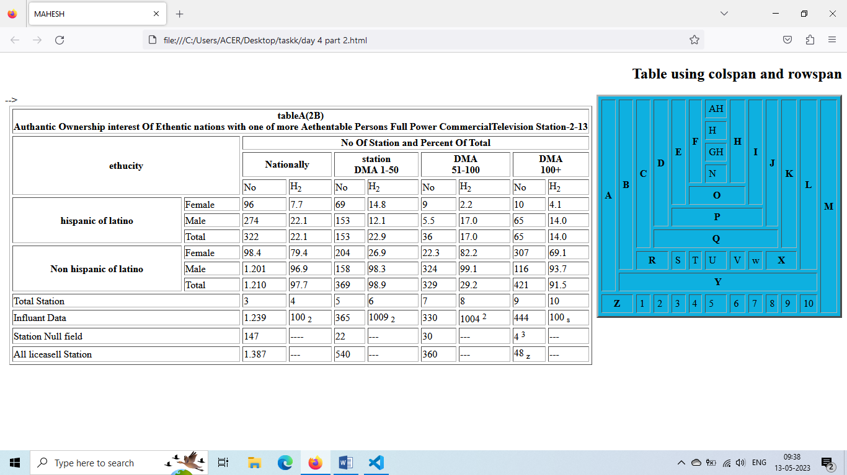

6. Create below table using HTML table tags

ANS :

<!DOCTYPE html>

<html lang="en">

<head>

    <meta charset="UTF-8">

    <meta http-equiv="X-UA-Compatible" content="IE=edge">

    <meta name="viewport" content="width=

    , initial-scale=1.0">

    <title>Document</title>

</head>

<body>

   <center> <table border="1" cellpading="5" cellspacing="1">

        <tr>

        <th colspan="14" bgcolor="green"> <font color="red">European Roulette</font></th>

        <!-- <td>2</td> -->

        <!-- <td>3</td> -->

        <!-- <td>4</td> -->

        <!-- <td>5</td> -->

        <!-- <td>6</td> -->

        <!-- <td>7</td> -->

        <!-- <td>8</td> -->

        <!-- <td>9</td> -->

        <!-- <td>10</td> -->

        <!-- <td>11</td> -->

        <!-- <td>12</td> -->

        <!-- <td>13</td> -->

        <!-- <td>14</td> -->

</tr>

<tr>

    <td rowspan="5" bgcolor="green"><font color="red">0</font></td>

    <td>2</td>

    <td>3</td>

    <td>4</td>

    <td>5</td>

    <td>6</td>

    <td>7</td>

    <td>8</td>

    <td>9</td>

    <td>10</td>

    <td>11</td>

    <td>12</td>

    <td>13</td>

    <td>14</td>

</tr>

<tr>

    <!-- <td>1</td> -->

    <td>2</td>

    <td>3</td>

    <td>4</td>

    <td>5</td>  <td>6</td>

    <td>7</td>

    <td>8</td>

    <td>9</td>

    <td>10</td>

    <td>11</td>

    <td>12</td>

    <td>13</td>

    <td>14</td>

</tr>

<tr>

    <!-- <td>1</td> -->

    <td>2</td>

    <td>3</td>

    <td>4</td>

    <td>5</td>  <td>6</td>

    <td>7</td>

    <td>8</td>

    <td>9</td>

    <td>10</td>

    <td>11</td>

    <td>12</td>

    <td>13</td>

    <td>14</td>

</tr>

<tr>

    <!-- <td>1</td> -->

    <td colspan="4" bgcolor="green"> <font color="red">1st12</font></td>

    <!-- <td>3</td> -->

    <!-- <td>4</td> -->

    <!-- <td>5</td>  -->

    <td colspan="4" bgcolor="green"> <font color="red">2nd12</font></td>

    <!-- <td>7</td> -->

    <!-- <td>8</td> -->

    <!-- <td>9</td> -->

    <td colspan="4" bgcolor="green"> <font color="red">3rd12</font></td>

    <!-- <td>11</td> -->

    <!-- <td>12</td> -->

    <!-- <td>13</td -->

    <td rowspan="2" bgcolor="green"></td>

</tr>

<tr>

    <!-- <td>1</td> -->

    <td colspan="2" bgcolor="green"><font>1to18</font></td>

    <!-- <td>3</td> -->

    <td colspan="2" bgcolor="green"><font>EVEN</font></td>

    <!-- <td>5</td>   -->

    <td colspan="2" bgcolor="red"></td>

    <!-- <td>7</td> -->

    <td colspan="2" bgcolor="black"></td>

    <!-- <td>9</td> -->

   <td colspan="2" bgcolor="green"><font>OOD</font></td>

    <!-- <td>11</td> -->

    <td colspan="2" bgcolor="green"><font>13to36</font></td>

    <!-- <td>13</td> -->

    <!-- <td>14</td> -->

</tr>

    </table></center>

</body>

</html>

Output :

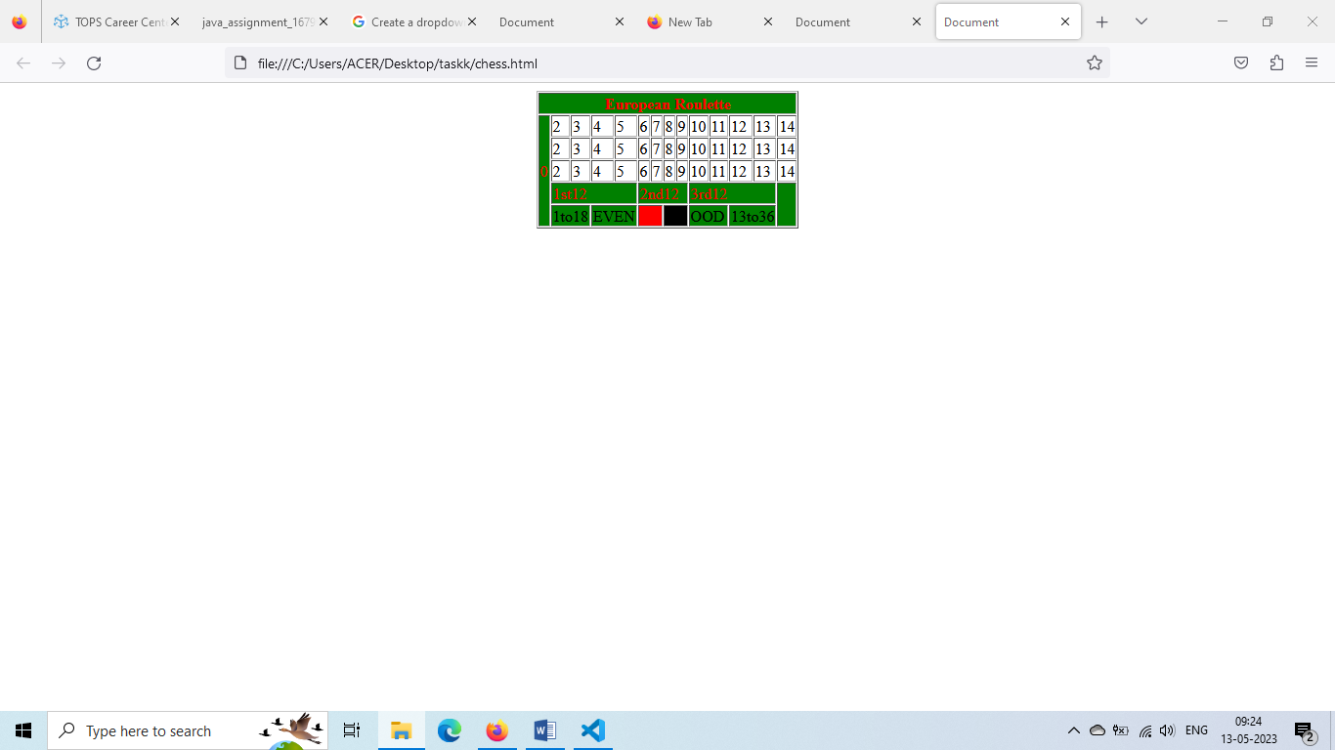

7. Create Registration form using HTML, CSS

ANS :

<!DOCTYPE html>

<html lang="en">

<head>

  <meta charset="UTF-8">

  <meta http-equiv="X-UA-Compatible" content="IE=edge">

  <meta name="viewport" content="width=device-width, initial-scale=1.0">

  <title>Registraration Form</title>

</head>

<style>

  * {

    margin: 0;

    padding: 0;

  }

  div {

    margin-left: 30px;

    padding-left: 5%;

     background-color: azure;

  }

  h1 {

    margin: 40px;

    color: red;

    text-align: center;

  }

   /* first name */

   .fname{

    margin-left: 100px;

    height: 30px;

    width: 500px;

    background-color: white;

   }

     /* last name */

   .lname{

    margin-left: 102px;

    height: 30px;

    width: 500px;

    background-color: white;

   }

   .email{

    margin-left: 133px;

    height: 30px;

    width: 500px;

    background-color: white;

   }

   .mobile{

    margin-left: 125px;

    height: 30px;

    width: 500px;

    background-color: white;

   }

   .gender{

    margin-left: 123px;

    background-color: white;

   }

   /* date of birth */

   .dob{

    margin-left: 85px;

    height: 30px;

    width: 500px;

    background-color: white;

   }

   /* address */

   .add{

    margin-left: 180px;

    width: 500px;

    background-color: white;

   }

   .city   {

    margin-left: 139px;

    height: 30px;

    width: 500px;

    background-color: white;

   }

   /* pincode */

   .pin   {

    margin-left: 110px;

    height: 30px;

    width: 500px;

    background-color: white;

   }

   .state {

    margin-left: 135px;

    height: 30px;

    width: 500px;

    background-color: white;

   }

   /* password */

   .pass {

    margin-left: 104px;

    height: 30px;

    width: 500px;

    background-color: white;

   }

   /* qualification */

   .qua {

    margin-left: 82px;

    height: 30px;

    width: 500px;

    background-color: white;

   }

   /* computer */

   .com  {

    margin-left: 177px;

    background-color: white;

   }

    /* information technology */

   .in{

    margin-left: 177px;

    background-color: white;

   }

   .ca {

    margin-left: 177px;

    background-color: white;

   }

   /* tele communication */

   .tele{

    margin-left: 177px;

    background-color: white;

   }

   .btn{height: 30px;

   width: 100px;

   background-color: green;

   }

</style>

<body>

    <H1 >Student Registraration Form</H1>

     <!-- first name -->

    <div>

    <label for="" >First Name : </label>

    <input type="button" class="fname" value="Enter your first  name   ">

    <br>

    <!-- last name -->

    <label for=""> Last Name : </label>

    <input type="button" class="lname" value="Enter your Last name   "><br>

     <!-- email -->

    <label for="">Email :</label>

    <input type="button" class="email" value="it should contain  @..   "><br>

     <!-- mobile -->

    <label for=""> Mobile :</label>

    <input type="button" class="mobile" value="only 10 disit are allowed"><br>

        <!-- gender -->

    <label for=""> Gender : </label>

    <input type="radio" class="gender"  id="html" name="fav_language" value="Male">

    <label for="html" >Male</label>

    <input type="radio" id="css" name="fav_language" value="Female">

    <label for="css">Female</label><br>

    <label for="">Date of Birth :</label>

    <input type="datetime-local" class="dob"> <br>

       <!-- address -->

    <label for ="" >Address :</label> <br>

    <textarea id="subject" name="Address" class="add" placeholder="" style="height:220px"></textarea>

        <br>

    <label for="">City : </label>

    <input type="text" class="city">

         <br>

    <label for="">Area PIN: </label>

    <input type="text" class="pin">

           <br>

    <label for="">State : </label>

    <input type="text" class="state">

             <br>

      <label for="">Qualification :</label>

        <!-- <label for="qua">Select Qualification: </label> -->

<select id="qua" class="qua">

  <option label="Select Qualification: "></option>

  <option label="Arts"></option>

  <option label="Commerce"></option>

  <option label="Science"></option>

</select>

            <br>

     <label for="">Specialization : </label> <br>

     <input type="checkbox" class="com">

     <label for="">Computer Science</label>

     <br>

     <input type="checkbox" class="in">

     <label for="">Information Technology</label>

     <br>

     <input type="checkbox" class="ca">

     <label for="">Computer Architecture</label>

       <br>

       <input type="checkbox" class="tele">

     <label for="">Tele Communication</label> <br>

     <label for="">Password :</label>

     <input type="text" class="pass"> <br>

     <button class="btn">Registered</button>

  </div>

</body>

</html>

Output :

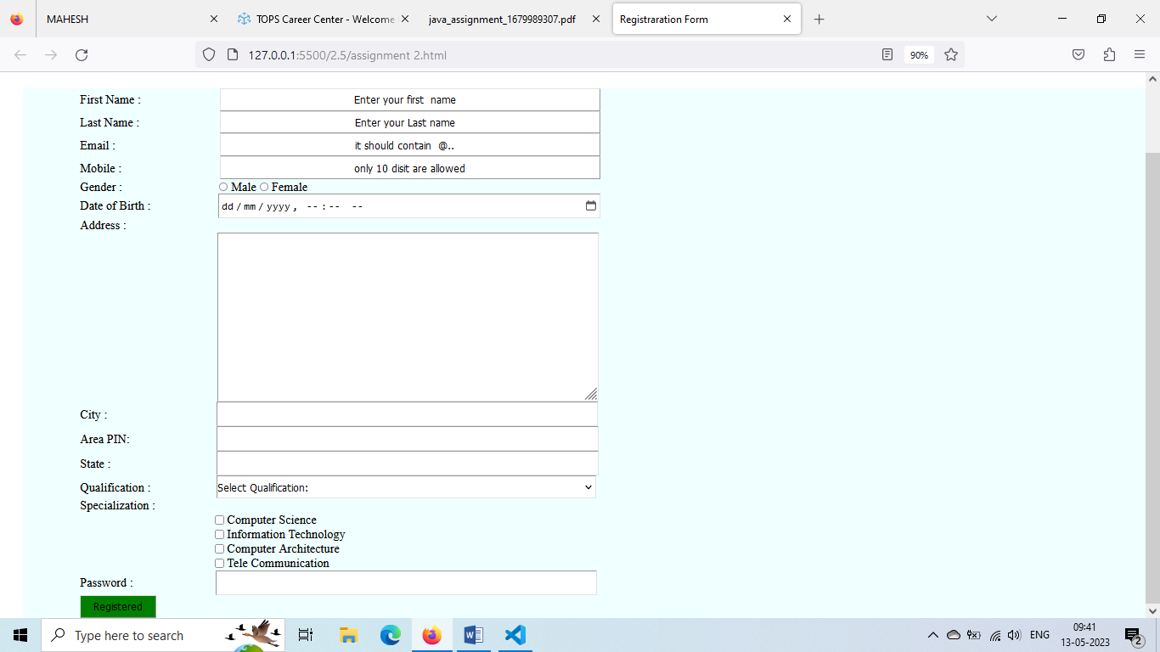

8. In how many ways can a CSS be integrated as a web Page ?

ANS :

**There are three ways of inserting a style sheet:**

External CSS.

Internal CSS.

Inline CSS

9. Create simple three pages using External CSS, Internal CSS, and Inline  
CSS.

ANS :

External CSS

<!DOCTYPE html>

<html lang="en">

<head>

    <meta charset="UTF-8">

    <meta http-equiv="X-UA-Compatible" content="IE=edge">

    <meta name="viewport" content="width=device-width, initial-scale=1.0">

    <title>Document</title>

    <link rel="stylesheet" href="stle.css">

</head>

Internal CSS

<!DOCTYPE html>

<html lang="en">

<head>

    <meta charset="UTF-8">

    <meta http-equiv="X-UA-Compatible" content="IE=edge">

    <meta name="viewport" content="width=device-width, initial-scale=1.0">

    <title>Document</title>

    <style>

        select{

            color: aqua;

        }

    </style>

Inline CSS

<body>

    <select id="qua" class="qua" style="color: aqua;">

        <option label="Select Qualification: "></option>

        <option label="Arts"></option>

        <option label="Commerce"></option>

        <option label="Science"></option>

      </select>

10. Create below page using HTML CSS

ANS :

<!DOCTYPE html>

<html lang="en">

<head>

    <meta charset="UTF-8">

    <meta http-equiv="X-UA-Compatible" content="IE=edge">

    <meta name="viewport" content="width=device-width, initial-scale=1.0">

    <title>Document</title>

</head>

<style>

    *{

        margin: 0;

        padding: 0;

    }

    form{

      color: blue;

        padding-top: 50px;

        padding-left: 100px;

        background-color: rgba(121, 221, 196, 0.521);

    }

    .user{

        color: red;

        height: 30px;

    }

    .login{

        padding: 30px;

      margin-left: 700px;

      height: 30px;

    }

    .id{

      height: 30px;

      width: 250px;

    }

    .pass{

        padding: 10px;

      margin-left: 713px;

      height: 30px;

    }

    .pas{

        margin-left: 21px;

      height: 30px;

      width: 250px;

    }

    .con{

        padding: 10px;

      margin-left: 660px;

      height: 30px;

    }

    .conp{

        margin-left: 20px;

      height: 30px;

      width: 250px;

    }

    .sal{

        padding: 10px;

      margin-left: 222px;

      height: 30px;

    }

    .btn{

        height: 30px;

        width: 100px;

    }

    .sel{

        height: 30px;

     width: 100px;

}

      .mid{

        padding: 10px;

      margin-left: 173px;

      height: 30px;

    }

    .mn{

      margin-left: 29px;

      height: 30px;

      width: 250px;

    }

     .fname{

        padding: 10px;

      margin-left: 450px;

      height: 30px;

    }

    .fn{

      height: 30px;

      width: 250px;

    }

    .lname{

        padding: 10px;

      margin-left: 300px;

      height: 30px;

    }

    .ln{

      margin-left: 2px;

      height: 30px;

      width: 250px;

    }

     .res{

        margin-left: 207px;

      height: 30px;

    }

    .sta{

        height: 30px;

        width: 100px;

    }

    .rs{

        height: 30px;

     width: 200px;

}

    .co{

        height: 30px;

     width: 200px;

}

 .coun{

        margin-left: 385px;

      height: 30px;

    }

    .email{

        padding: 10px;

      margin-left: 203px;

      height: 30px;

    }

    .ei{

      margin-left: 29px;

      height: 30px;

      width: 250px;

    }

    .mobile{

        padding: 10px;

      margin-left: 276px;

      height: 30px;

    }

    .no{

      margin-left: 29px;

      height: 30px;

      width: 250px;

    }

    .disit{

        padding: 10px;

      margin-left: 133px;

      height: 30px;

    }

    .di{

      margin-left: 29px;

      height: 30px;

      width: 250px;

    }

    .fund{

        padding: 10px;

      margin-left: 193px;

      height: 30px;

    }

    .btn{

        height: 30px;

        width: 100px;

    }

    .ft{

        height: 30px;

     width: 100px;

}

.para{

  word-spacing: 2px;

  margin-left: 5%;

  height: 300px;

  width: 90%;

  color: blue;

}

    .sub{

      margin-left: 300px;

      background-color: green;

      height: 30px;

      width: 100px;

    }

    .rec{

      background-color: green;

      height: 30px;

      width: 100px;

    }

</style>

<body>

    <div>

        <form action="">

          <label for="" class="user">User perticulars</label> <br>

          <label for="" class="login">* Login Id </label>

          <input type="button" value="" class="id">

         <br>

         <label for="" class="pass">* Password</label>

         <input type="button" value="" class="pas">

        <br>

        <label for="" class="con">*Confirm Password</label>

         <input type="button" value="" class="conp">

      <br>

      <label for="" class="user">Personal perticulars</label> <br>

      <label for="" class="sal">* Salutation</label>

      <select name="" id="" class="sel">

        <button class="btn">

            <option value="">Select

            </option>

        </button>

        </select>

        <label for="" class="fname"> *First Name</label>

        <input type="button" value="" class="fn">

        <br>

        <label for="" class="mid"> *Middle Name</label>

        <input type="button" value="" class="mn">

        <label for="" class="lname"> *Last Name</label>

        <input type="button" value="" class="ln">

     <label for="" class="res">* Resident Status</label>

      <select name="" id="" class="rs">

        <button class="sta">

            <option value="">Select

            </option>

        </button>

        </select>

        <label for="" class="coun">* Country</label>

      <select name="" id="" class="co">

        <button class="co">

            <option value="">Select

            </option>

        </button>

        </select>

       <br>

       <label for="" class="email"> *Email Id </label>

        <input type="button" value="" class="ei">

        <label for="" class="mobile"> *Mobile No</label>

        <input type="button" value="" class="no">

          <br>

          <label for="" class="user">Account perticulars</label>

          <br>

         <label for="" class="disit"> *15 Disit Mobile No</label>

        <input type="button" value="" class="di">

        <label for="" class="mobile"> *Nick Name</label>

        <input type="button" value="" class="no">

       <br>

       <label for="" class="fund">* Fund Transfer</label>

      <select name="" id="" class="ft">

        <button class="btn">

            <option value="">Select

            </option>

        </button>

        </select>

        <br>

      <label for="" class="user">DECLARATION</label> <br>

       <div class="para">

        I have read,understood and hereby agree to the Terms and Conditions in respect of all products and <br> channels.  <br>

         I understand that any changes in the terms and condition applicable to this relationship would be made <br> available to me on request at any IOB branches. I confirm that all accounts under this login name are <br> operated singty and in case of joint account operated by either or survivor/anyone or survivor(s) under his/her joint name respectively. <br>

         I do hereby declare that information furnished in this form is true to the best of my knowledge and belief.

       <br>

       <button class="sub">submit</button>

       <button class="rec">recet</button>

       </div>

        </form>

    </div>

</body>

</html>

Output:

